Python Assessment

**1)SAY Hello,World! With python**

**2)PYTHON IF-ELSE**

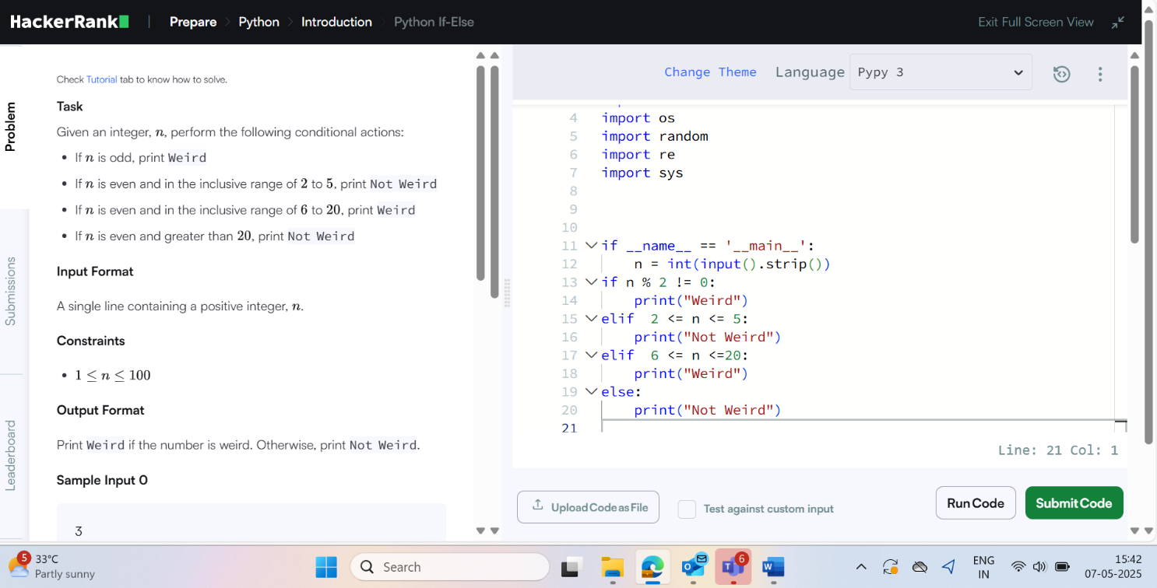

**3)ARITHMETIC OPERATORS**

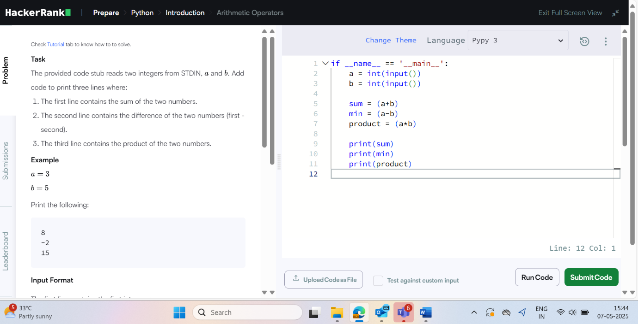

**4)PYTHON-DIVISION**

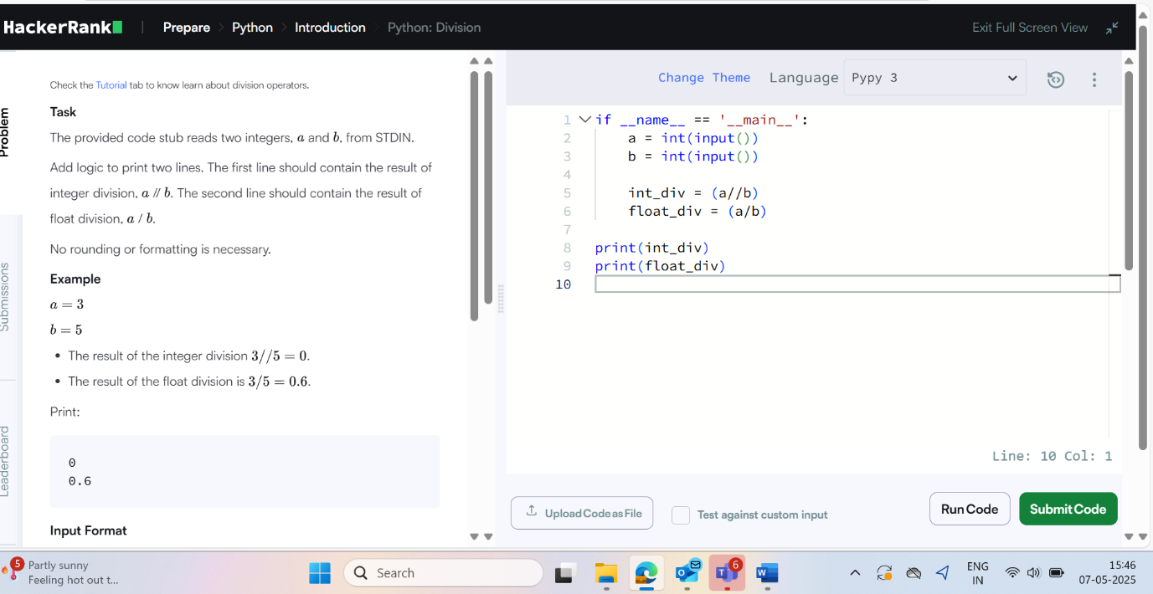

**5)WRITE A FUNCTION**

